Cryptography Activity – E-Portfolio Post
For this activity, I selected Fernet symmetric encryption from the TutorialsPoint cryptography material because it is designed for practical file encryption in Python and uses the cryptography library to encrypt file contents with a generated secret key. TutorialsPoint also shows Fernet as a method for encrypting files directly, which made it a good fit for the task requirement.
Created a file called: encrypt_app.py
from cryptography.fernet import Fernet
from pathlib import Path

# Generate and save a key
def generate_key(key_file="secret.key"):
key = Fernet.generate_key()
Path(key_file).write_bytes(key)
return key

# Load an existing key
def load_key(key_file="secret.key"):
return Path(key_file).read_bytes()

# Encrypt a short piece of text
def encrypt_text(text, key):
cipher = Fernet(key)
encrypted = cipher.encrypt(text.encode())
return encrypted

# Encrypt a text file and save the encrypted output
def encrypt_file(input_file, output_file, key):
cipher = Fernet(key)
data = Path(input_file).read_bytes()
encrypted_data = cipher.encrypt(data)
Path(output_file).write_bytes(encrypted_data)

# Main program
if __name__ == "__main__":
key_path = "secret.key"

if not Path(key_path).exists():
key = generate_key(key_path)
print("New key generated.")
else:
key = load_key(key_path)
print("Existing key loaded.")

# Short text example
sample_text = "This is a short confidential message."
encrypted_text = encrypt_text(sample_text, key)
print("Encrypted text:", encrypted_text)

# File encryption example
input_filename = "sample.txt"
output_filename = "sample_encrypted.txt"

if Path(input_filename).exists():
encrypt_file(input_filename, output_filename, key)
print(f"Encrypted file created: {output_filename}")
else:
print(f"Input file '{input_filename}' not found.")

How I tested it
I created a text file called sample.txt in the same folder as the notebook/script, ran the program, and it produced:
- secret.key
- sample_encrypted.txt
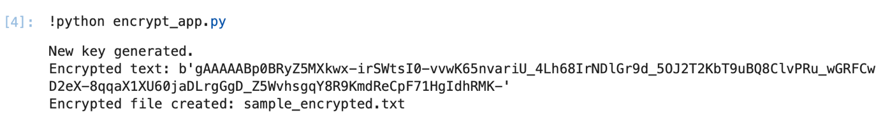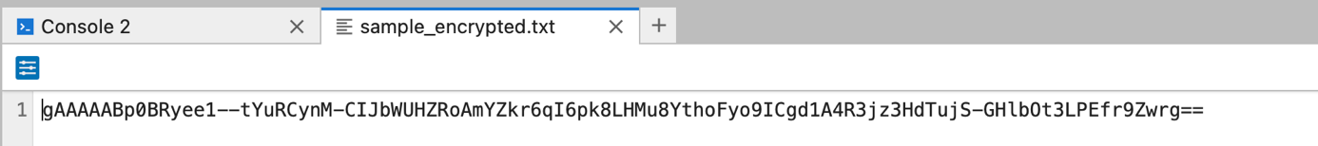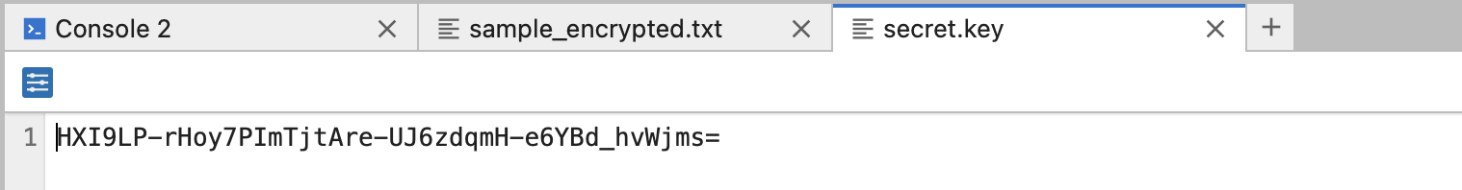
The original text file remained readable, while the encrypted output file contained unreadable ciphertext.

Why I selected this algorithm
I chose Fernet because it is simpler and more realistic for protecting files than older classical ciphers such as Caesar or transposition. TutorialsPoint describes Fernet as a file-encryption approach in Python, and the wider TutorialsPoint material also explains that Fernet in the cryptography package is a high-level symmetric encryption method built on AES with authentication.
In practical terms, I chose it because:
- it is easy to implement in Python
- it works well for both short text and files
- it is much stronger than simple substitution methods
- it includes authenticated encryption, so tampering can be detected

Would it meet GDPR regulations?
Potentially yes, but not by itself. GDPR does not mandate one specific encryption algorithm, but it does recognise encryption as an important technical measure for protecting personal data under Article 32. Whether my program would meet GDPR expectations depends not just on the algorithm, but on how the whole system handles keys, access, storage, and deletion.
My justification:
- Strength: Fernet is far more appropriate than simple educational ciphers because it uses modern symmetric encryption and message authentication.
- Limitation: In my demo, the encryption key is stored locally in secret.key. If an attacker gains access to that key, the encrypted file can be decrypted.
- GDPR view: The encryption method helps with confidentiality, but GDPR compliance would also require secure key management, access control, minimisation of stored personal data, and broader organisational controls.
So, for a classroom demonstration, this is a sensible and defensible choice. For a real GDPR-compliant system, I would improve it by:
- storing keys securely, not beside the data
- restricting file and key access
- adding audit logging and access controls
- defining retention and deletion procedures

Reflection
This task helped me move from simple shell and API exercises into a more security-focused practical activity. It showed that encryption is not only about scrambling data, but also about how the key is managed. That links directly to secure system design and to GDPR, where confidentiality depends on the surrounding controls as much as the algorithm itself.

